St Oswald’s Catholic Primary School
Feedback and Marking Policy

At St Oswald’s, we recognise the importance of feedback as an integral part of the teaching and learning cycle, and aim to maximise the effectiveness of its use in practice. We are mindful also of the research surrounding effective feedback and the workload implications of written marking, as well as research from cognitive science regarding the fragility of new learning.
Our policy is underpinned by the evidence of best practice from the Education Endowment Foundation and other expert organisations. The Education Endowment Foundation research shows that effective feedback should:
- Redirect or refocus either the teacher’s or the learner’s actions to achieve a goal
- Be specific, accurate and clear
- Encourage and support further effort
- Be given sparingly so that it is meaningful
- Put the onus on students to correct their own mistakes, rather than providing correct answers for them
- Alert the teacher to misconceptions, so that the teacher can address these in subsequent lessons.
Notably, the Department for Education’s research into teacher workload has highlighted written marking as a key contributing factor to workload. As such we have investigated alternatives to written marking which can provide effective feedback in line with the EEF’s recommendations, and those of the DfE’s expert group which emphasises that marking should be: Meaningful, manageable and motivating. We have also taken
note of the advice provided by the NCETM (National Centre for Excellence in Teaching Mathematics) that the most important activity for teachers is the teaching itself, supported by the design and preparation of lessons.

Key Principles
Our policy on feedback has at its core a number of principles:
- The sole focus of feedback should be to further children’s learning;
- Evidence of feedback is incidental to the process; we do not provide additional evidence for external verification;
- Feedback should empower children to take responsibility for improving their own work; it should not take away from this responsibility by adults doing the hard thinking work for the pupil.
- Written comments should only be used as a last resort for the very few children who otherwise are unable to locate their own errors, even after guided modelling by the teacher.
- Children should receive feedback either within the lesson itself or it in the next appropriate lesson.
The ‘next step’ is usually the next lesson.
- Feedback is a part of the school’s wider assessment processes which aim to provide an appropriate
level of challenge to pupils in lessons, allowing them to make good progress.
- New learning is fragile and usually forgotten unless explicit steps are taken over time to revisit and refresh learning. Teachers should be wary of assuming that children have securely learnt material based on evidence drawn close to the point of teaching it. Therefore, teachers will need to get feedback at some distance from the original teaching input when assessing if learning is now secure.

Within these principles, our aim is to make use of the good practice approaches outlined by the EEF toolkit to ensure that children are provided with timely and purposeful feedback that furthers their learning, and that teachers are able to gather feedback and assessments that enable to adjust their teaching both within and across a sequence of lessons.

Feedback and marking in practice
It is vital that teachers evaluate the work that children undertake in lessons, and use information obtained from this to allow them to adjust their teaching. Feedback occurs at one of four common stages in the learning process:
- Immediate feedback – at the point of teaching
- Summary feedback - at the end of a lesson/task
- Next lesson feedforward – further teaching enabling the children to identify and improve for themselves areas for development identified by the teacher upon review of work after a previous lesson had finished
- Summative feedback – tasks planned to give teachers definitive feedback about whether a child has securely mastered the material under study

These practices can be seen in the following practices:

Type | What it looks like | Evidence (for observers)
Immediate | - Includes teacher gathering feedback from teaching within the course of the lesson, including mini-whiteboards, bookwork, etc.  - Takes place in lessons with individuals or small groups  - Often given verbally to pupils for immediate action  - May involve use of a teaching assistant to provide support of further challenge  - May re-direct the focus of teaching or the task | - Lesson observations/learning walks
Summary | - Takes place at the end of a lesson of activity  - Often involves whole groups or classes  - Provides an opportunity for evaluation of learning in the lesson  - May take form of self or peer- assessment against an agreed set of criteria  - May take the form of a quiz, test or score on a game  - In some cases, may guide a teacher’s further use of review feedback, focusing on areas of need | - Lesson observations/learning walks  - Some evidence of self –  and peer-assessment  - Quiz and test results may be recorded in books or logged separately by the teacher
Feedforward: ‘the next step is the next lesson’ | - For writing in particular, often a large part of the next lesson will be spent giving feedback to the class about strengths and areas for development and giving time for development areas to be worked on and improved through proof reading and editing their work.  - “Do nows” are analysed daily and errors and misconceptions addressed in subsequent lessons, in particular in maths meetings. | - Lesson observations/learning walks  - Evidence in books of pupils editing and redrafting their work in green pen
Summative | - ‘Check it’ activities  - End of unit or term tests or quizzes | - Check it activities in books  - Quiz and test results

Guidance for teachers

Proof reading and editing in writing lessons
Most writing lessons will be followed up with an editing lesson where children receive whole class feedback about strengths and areas for development and direct teaching of writing to help them identify and address their own weaknesses.
Teachers will have looked at pupils’ work soon after the previous lesson and identified strengths and weaknesses, looking at both the technical accuracy of the writing; spelling errors, punctuation omissions, and other transcription mishaps as well as things to do with the sophistication of the writing; the actual content. Where individual children have done particularly well or badly at something, s/he will make a note and use these in the lesson as a teaching point.
The editing lesson will be divided into two sections
- proofreading
Changing punctuation, spelling, handwriting and grammar mistakes.
- editing
Improving their work to improve the composition.
The proofreading section will usually be short: about 10 minutes or so, whereas the editing element may take the rest of the lesson.
The teacher will share extracts from pupils’ work, using either via the whiteboard or by typing out a couple of lines and displaying them on the interactive whiteboard, at first showing good examples of work. For example, within the proof reading section, the teacher might showcase someone whose letter heights have the ascenders and descenders just right, then asking pupils to look at their work and rewrite one sentence from it, really making sure they are paying attention to letter heights. Then s/he might share a section of text with poor punctuation (usually anonymously) and reteach the class the various punctuation rules. They might then point out some spelling errors that several children are making, and remind children of the correct spelling and how to remember it. Children will then have a short period of time to proof read their work, checking for similar errors and putting them right. Children could sit in mixed ability pairs and support each other in the identification and correction of mistakes.
Within the editing section of the lesson. For example, the teacher might show a different couple of pieces of work where children have described a character very well, pointing out what it is that has made the description so vivid. The teacher might then share a less good example which might be from an anonymous or fictional piece. The children would then suggest together how this might be improved. Then in their pairs
they read together each other’s work, and suggest improvements, alterations and refinements which the
author of the piece then adds – in green pen to help the teacher see what changes the child has made.

Intervening when children find editing hard
A few children will need more support than this in order to be successful at improving their own work. Younger children in KS1 in particular may need more support as they learn to become more independent, although many young children are quite able to edit and proof read independently after teacher modelling.
As with all intervention, teachers should always seek to use the minimal level possible, only escalating to the next level if the child still needs further support. Some children may need a gentle prompt to narrow down their focus when looking for mistakes, for example a written comment alerting them that there are some missing full stops, without telling them how many or where. Or a simple pointer – ‘description’ perhaps or
‘ambiguous pronouns’ or ‘figurative language’ or ‘and then’ with a red cross through it. This would be in addition to, and not instead of, the teacher modelling editing for these before the independent section of the lesson. Others might need even more support and need to be provided with clues to help them. For example, the teacher might need to draw a yellow box around a section of text to narrow down the search area for the pupil, alongside the comment that there are speech marks missing or tenses jumped or the same sentence structure over-used. Or they might need to write a comment at the end saying there are 8 run-on sentences or 5 instances of non-standard English. The ‘Crimes Against Writing’ prompt sheets (see appendix) should be used with KS2 classes until these basic skills are securely in place for most of the class. Certain individuals may need to carry on referring to these longer until the checklist is thoroughly internalised.

Where mistakes are deeply entrenched, or the children are very young and lack confidence, the teacher may need to do some direct work modelling how to overcome these: for example, to clear up the confusion with apostrophe use. The teacher might set a group of children an editing challenge based not on their own work but on a fictional piece of work with only one, recurrent error. An adult might then support the group in identifying where apostrophes do and do not belong. They might do this instead of editing their own work or as a prelude to it, depending upon their learning needs. But what the teacher is not doing is using a marking code that does all the error identification for the pupil as this takes away any responsibility from the pupil at thinking hard about how to improve.

The strategical minimal marking triangle

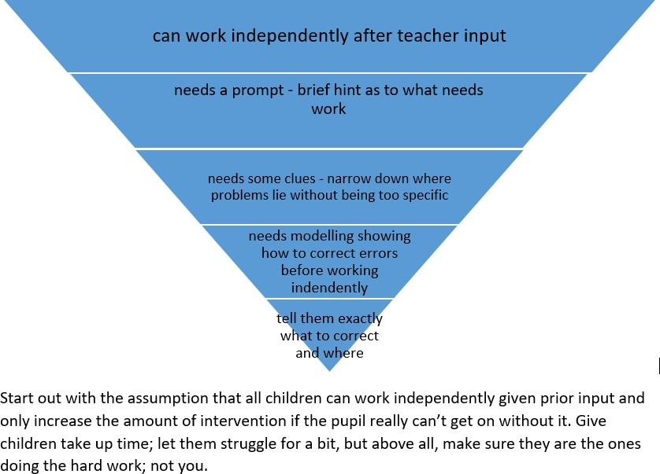

Sometimes it is children who find writing easy who do not challenge themselves to improve their writing through editing, settling too readily for their first attempt. These children may initially need specific clues about what an ever better piece of writing might look like.
- Set group or individual challenges, “before you’ve finished editing, you need to have…
- Use their work in modelling and then expect them to do the same.

Feedback in maths
Teachers gain valuable feedback about how much maths teaching is being retained in the longer term from the daily starter sessions at the start of lessons in ks1 and lower ks2. This information should be used to revisit areas where learning is not secure within maths lessons. ‘Check it tasks’ given at least 3 weeks after teaching a unit and end of unit tests also provide vital feedback to the teacher about areas that might need more teaching for certain individuals either in class or through an intervention.
In terms of day to day maths learning, in ks2, teachers should have the answers to problems available, and after doing 4 or 5 calculations, children should check their answers themselves. That way, if they have got the wrong end of the stick and misunderstood something, they can alert the teacher immediately. Another benefit is that less confident children might want to start at the easiest level of work provided, but with instant feedback available, after getting their first few calculations correct, they feel confident to move to the next level. Another strategy teachers can use is to get children to compare answers in a group and where answers do not agree, challenge each other and try and find where the other person has gone wrong.
Where children are more confident, and finish their work slightly earlier than others, they can consolidate
their learning by ‘marking’ other children’s books. When they do this, the crucial step is that they should not

take their own book with them and just read off the correct answer. They should do the calculations again – faster and possibly mentally – so in effect doing the work twice thus getting the sort of over-learning that leads to solid long-term retention.
The onus is always on the learner checking their work and if they’ve got an answer wrong, trying to identify their own errors. Children need to be taught how to do this purposely; otherwise they think it just means scanning quickly through their work, reading but not really thinking. Checking involves thinking deeply about the work you have just learnt. When you think deeply about something, it is much more likely to get stored in your long term memory, available to be recalled at will. As Daniel Willingham says ‘memory is the residue of thought.’ So as an alternative to providing the answers, teachers should sometimes use the whiteboard to model ways of checking and then expect children to do the same, in effect ‘proof reading’ maths. So for
example, children might repeat a calculation in a different coloured pen and check they’ve got the same answer. For addition calculations involving more than two numbers, adding the numbers in a different order is an even better way of checking. Teachers should model how children can use the inverse operation to go and check they get back to where they started.
With 2 or 3 part word problems, a classic error is to give the answer as the first part of the problem and forget about following through to the second (or third) part of the question. Often, word problems are written with each instruction on a different line, a bit like success criteria. Again, using a whiteboard, teachers should show children how to check work as we go, returning to the question and ticking off each line – writing each answer alongside, being really clear we are answering the final question, having done all of the previous steps.
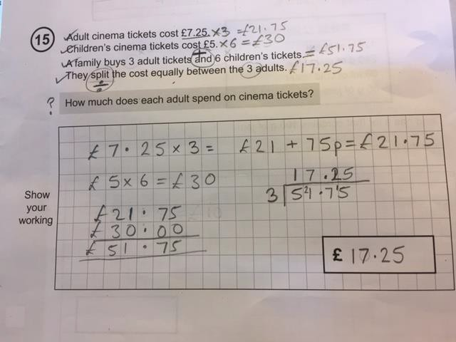
Where children have made mistakes, and are finding it hard to identify where they have gone wrong, a prompt sheet, shared with the class at the start of the lesson, can help. In effect, this is just a process success criteria, but recasting it as a checklist to be used to identify errors means children use it thoughtfully and only when needed.
Find my mistake (column addition)
- Did I put each numeral in the right place value column? Check each one.
- Did I forget to regroup?
- Did I forget to add the regrouped ten (or hundred)?
- Did I make a silly error with my adding?
- If you can’t find your mistake, ask your partner to go through this checklist with you and see if they can help

- If you are still stuck, is there another child who looks like they are confident with this you could ask?
- If none of this works, ask an adult for help.

Find my mistake (identifying fractions of shapes)
- Did I check all the parts were equal?
- Did I count how many parts the shape had been divided into?
- Did I write that number underneath the vinculum (remember denominator→down)
- Did I count how many parts were shaded in?
- Did I write that number on top of the vinculum (remember numerator →oN top)
- If you can’t find your mistake, ask your partner to go through this checklist with you and
see if they can help
- If you are still stuck, is there another child who looks like they are confident with this you could ask?
- If none of this works, ask an adult for help.

It is important that the children move towards internalising what they are doing (over the course of several lessons) so that they no longer need a written checklist because they have their own mental checklist stored in their long term memory, which they are able to retrieve at will. Giving children work to ‘mark’ from fictitious other children, which includes all the common misconceptions, is a really good way of helping them develop this.

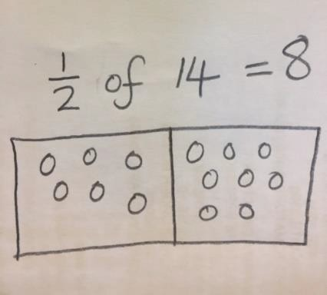

Date new policy adopted February 2019.
Date previous policy reviewed September 2018
Sources: Education Endowment Foundation. Report-A Marked Improvement? C Sealy on twitter and conference slides. C Sealy Feedback Policy. Ofsted Myth Busting Document. Ofsted Working review Group on Workload.

SMT and all staff have had input.

Date of review- February 2020

Have you committed any writing crimes?

Proof-read your work and correct these mistakes to fix any crimes against writing!

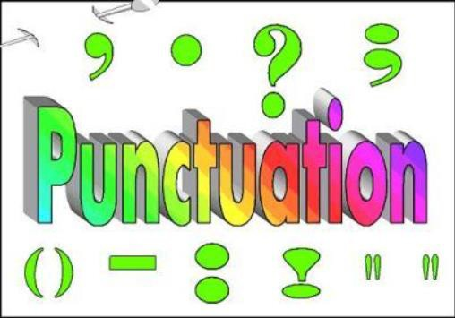

It is a crime to forget that:
- Every sentence starts with a capital letter.

- Every proper noun starts with a capital letter.

- We do not need random capital letters in the middle of words.

- All sentences must end with punctuation. . ! ? ...

- I is always a capital letter when alone or in a contraction as a pronoun.
- Questions always end with a ?

- Contractions always need an apostrophe to replace the missing letter or letters. EG: don’t wouldn’t can’t
- You only need an apostrophe before an s if you are showing something belongs to something else. EG:
The boy’s coat, the horse’s leg, the school’s badge.

It is a crime to forget:

Past tense verbs must be spelt correctly- remember sometimes it sounds like id, t or d but is spelt ed.
- We use an before words beginning with a vowel and a before words beginning with a consonant. EG
- I saw an elephant and a giraffe.
- We use was when the subject is singular (one person or thing) and
were when you are writing about more than one person or thing. EG

Today was amazing, we were so lucky to go on that trip.

Your personal spelling crimes!

Make sure these words are spelt correctly every time!

