Leader/Co-ordinator | Miss P Malley
Groups involved in discussion | Headteacher  RE Co-ordinator  All Staff  Governing Body
Policy for Religious Education
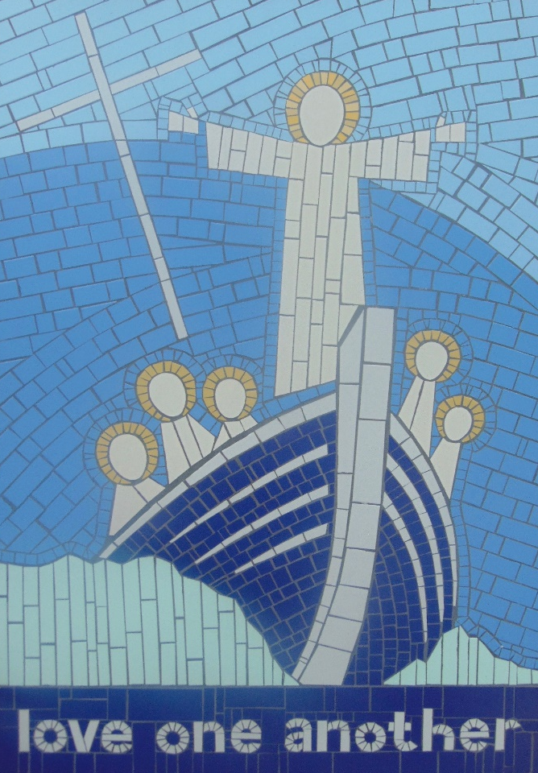
In the life of faith of our Catholic School, religious education plays a central and vital part. At St Oswald’s for all children, Religious Education is a cross curricular subject. It is a rigorous academic discipline and as such is taught, developed and resourced with the same commitment as any other subject. It is very much the core subject. The beliefs and values studied in Catholic Religious Education inspire and draw together every aspect of the life of our Catholic School.
We are committed to Catholic RE because all pupils have the right to receive an overall religious education. RE is for all and is a collaborative activity, which respects and promotes the child’s innate capacity for wonder, awe, reverence and imagination.
At St Oswald’s we aim to educate the whole person. At the heart of the school is a sense of purpose, which is to create a community that shares the values of love, respect, truth and reconciliation as shown through the example of Christ.
The Aims of Religious Education
“We are a learning community promoting the Gospel values of mutual, trust, care and respect”
As a school we ensure that all children and staff are treated fairly and equally. All children have equal rights to access all areas of the curriculum, regardless of race, gender and disability. Within this subject area, the SLT and all staff endeavour to provide the appropriate provision for this to occur. This policy follows guidelines and practices that are stated and outlined in St. Oswald’s Equality Scheme.

The overall aims of Religious Education at St Oswald’s are to provide:
- Knowledge and understanding of Catholic faith and life.
- Knowledge and understanding of the response of faith to the ultimate questions about human life, it’s origin and purpose.
- The skills required to engage in examination of and reflection upon Religious belief and practice.
- The teachings of the Church.

The Aims of RE
St Oswald’s Religious Education programme will: -
- Develop knowledge and understanding of God and Jesus and the central belief which Catholics hold
- Develop awareness and appreciation of Catholic beliefs and an understanding of its impact on personal and social behaviour.
- Encourage study, investigation and a rich language of religious experience- activities, stories, symbols, rituals, people and objects.
- Provide opportunity for celebration, prayer and reflection
- Develop appropriate skills and foster appropriate attitudes
- Include appropriate materials about other faiths

These are explored in a manner which encourages investigation and reflection by the pupils, develops the appropriate skills and attitudes and promotes free, informed and full response to God’s call in everyday life.
In the words of the Curriculum Directory 2012, the outcome of Catholic Religious Education is…
‘religiously literate young people who have the knowledge, understanding and skills – appropriate to their age, ability and capacity to think spiritually. Ethically and theologically, and who are aware of the demands of religious commitment in everyday life.’

Objectives
As part of the ‘Come and See’ Programme, there is a focus on other faiths aswell as the Christian themes which are explored in each year group. Judaism is studied every year along with one other faith. The following table shows which other faiths will be studied over the next 3 years.
To fulfil our aims and objectives we use the ‘Come and See’ Programme of Religious Education recommended by the Archdiocese of Liverpool. Come and See is of primary importance within school since its purpose is to unify and inspire every aspect of school life. The programme has been implemented in all year groups, this provides a Catholic framework for the teacher to explore the themes with all children from reception to Y6.
The Religious Education Programme

2016/17 | 2017/18 | 2018/19
Judaism | Judaism | Judaism
Islam | Hinduism | Sikhism
The following pages show an overview of the Themes and Topics over the year cycle of Come and See.
The process of delivering each of the topics in Come and See has three main stages, which enable pupils to develop knowledge, skills and attitudes.
Explore
Reveal
Respond
All classes follow their own appropriate year group programme with the exception of Class 7 (Y3/4) and Class 10 (Y5/6), which are mixed year group classes. Each year it is assessed by the RE co-ordinator and the Headteacher which year group programme these classes should follow.
Long Term Planning
Long Term Planning is the responsibility of the SLT. Each class has its own long term plan according to the programme of study for that particular year group.
Medium Term Planning
Medium Term Planning is the responsibility of the RE Co-ordinator. The medium term plan shows the start dates for each topic (each topic should have equal weighting and should take four weeks to complete), the content and focus of each theme, attainment targets, the three themes and topics and key concepts, skills and attitudes.
Short Term Planning
Short Term Planning is the responsibility of the class teacher. Planning is in the form of a Smart Notebook screens and a completed electronic plan, which is recommended by Liverpool Archdiocese.

Overview of Content

Planning

It should include: -
- Topic Page with key words and attainment targets displayed
- Mind Map- Pre learning/ Post learning activity
- Objectives and Success Criteria for every lesson
- Driver Words
- Key stages of process
- Differentiation and activities
- Use of other adults to support learning
- Resources
- Dates
- Reflection
- Evaluation
Informal Assessment
- General observation of children engaged in general tasks and activities.
- Observation of contributions made to classroom displays.
- Review: end of task, activity, lesson, topic.
- Marking of more formal written work.
- At the start of every topic children complete a pre-learning mind map based on their new topic title and what the words mean to them. At the end of the topic children review these by completing a post-learning mind-map on the page opposite to show their new learning from the topic.
- Children underline the driver words in learning challenges.
- Class teachers highlight the topic sheets which are stuck in each child’s book to show which level they are working at within each topic.
Formal Assessment
- One topic each term is identified by the Christian Education Team for formal assessment.

The Bishop’s requirement of 10 percent of curriculum teaching time is clearly indicated on the class timetables. This time does not include time for collective worships.
In Key Stage One and the Foundation Stage the time spent on RE each week is at least
In Key Stage Two and the Foundation Stage the time spent on RE each week is at least

Time Allocation for RE

Assessment
- Six children are identified from each year group usually 2 LA, 2 AA and 2 MA children. They become known as ‘benchmark children’. Their RE assessment tasks are tracked right from Reception through to Y6.
Self-Assessment
- Teachers communicate Learning Challenges to pupils in each lesson and these are broken down into success criteria.
- Pupils self-assess their learning at the end of each lesson against the success criteria.
- Pupils make a comment where appropriate in line with our assessment policy.

Recording provides evidence of achievement. It involves pupils in self-assessment and progress in dialogue with the teacher. It takes many forms:
- Notes from observations.
- Written comments in pupil’s books.
- Visual evidence- for example photographs. DVD’s
- Year Group Assessment and Evidence Files.
There are four dimensions to reporting in Religious Education:
- Provides feedback to pupils on their achievement and progress.
- Informs teachers and colleagues of the achievement of individual pupils and the areas studied by a class and year group.
- Informs parents of the progress and achievement of their child.
- Informs parents, governors, parish and external agencies of the content and quality of Religious Education being provided and the achievements of the pupils.
At St Oswald’s parents are given the opportunity on three occasions during the school year to meet with their child’s class teacher to receive verbal reports on the progress of their child. Parents also receive a written interim report and an individual RE end of year report.

Reporting and Recording
Aims and Purposes of Monitoring, Evaluation and Review
- To identify strengths and weaknesses in order to help us improve the quality of teaching and learning in our school for the benefit of our pupils.
- To make informed decisions from the basis of secure evidence and use this to develop corporate pr

Monitoring, Evaluating and Reviewing

priorities.
- To raise expectations and standards across all areas.
- To assist in target setting.
- To celebrate achievement and successes and provide evidence to support judgements.
- To support staff development.
- To ensure that all staff have a clear picture of standards and areas for development within their own classes, teams, whole school and curriculum areas.
Key Principles
- Monitoring standards is central to maintaining and improving, it is at the heart of school planning as it leads to evaluation and review, which identifies the starting point for development.
- Monitoring leads to action.
- Monitoring provides a means of obtaining an accurate picture of various aspects of school life and practices that involve the staff and children.
- Confidentiality must be respected at all times.
- It must involve head teacher, staff and governors as appropriate.
- The system must be manageable in terms of time and information and have an agreed focus.

We believe that it is essential that Home, School and Parish work very closely together in preparing each pupil for the Sacraments.
St Oswald’s Catholic Primary School fully supports the parish in their preparation of the children for the Sacraments of Confirmation, Eucharist and Reconciliation. Parents are invited to attend an initial meeting during which the process of preparation and the commitment is outlined. Input from the parish priest, school and catechists is given.
We follow the ‘With You Always’ Programme. This is a resource for parents and their children who are in Year 4. The resource encourages parents/carers and children to meet together with catechists, supported by the school to learn about the sacraments using the family catechesis method. Parents are the first and best teachers of their children in the ways of faith, as is made clear when the child is baptised.
Sacramental Preparation

Inclusion
As a school we ensure that all children and staff are treated fairly and equally. All children have equal rights to access all areas of the curriculum, regardless of race, gender and disability. Within this subject area, the SMT and all staff endeavour to provide the appropriate provision for this to occur. This policy follows the guidelines and practices that are stated and outlined in St. Oswald’s Equality Scheme.

DISCUSSED AND AGREED BY RELEVANT STAFF
DISCUSSED AND AGREED BY GOVERNING BODY
MONITORING AND EVALUATION | Ongoing
REVIEW DATE(S)

