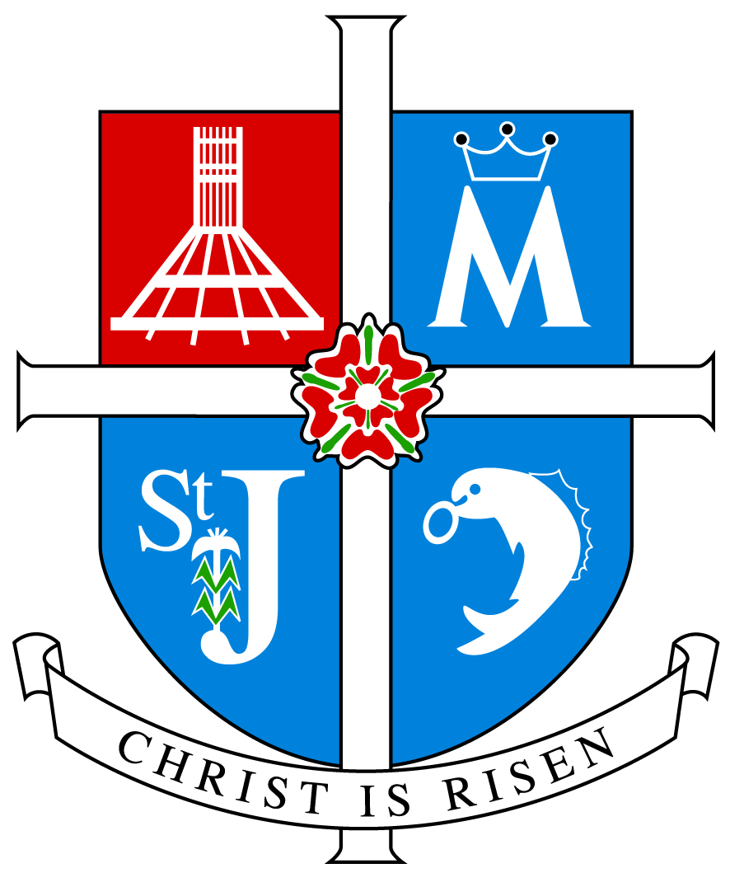

ARCHDIOCESE OF LIVERPOOL

INSPECTION REPORT

ST OSWALD’S

ASHTON-IN-MAKERFIELD

Inspection Date 12 November 2013

Inspectors Rev D Melly, Miss J Mosinski, Mrs M Buckley

Unique Reference Number 106488

Inspection carried out under Section 48 of the Education Acts 2005 and 2011
__________________________________________________________________

Type of School Catholic Primary

Age range of pupils 4-11

Number on roll 351

Chair of Governors Mr K Stout

Headteacher Mrs P Carter

School address Council Avenue
Ashton-in-Makerfield
Wigan
WN4 9AZ

Telephone number 01942 724820

E-mail address enquiries@admin.saintoswalds.wigan.sch.uk

Date of last inspection 4 November 2008

Introduction

This inspection was carried out under Section 48 of the Education Acts 2005 and 2011

The report of the inspection is produced for the Archbishop of Liverpool (Code of Canon Law 804 and 806) and for the governors of the school.

The inspectors are members of the Christian Education Department and their associates approved by the Archbishop of Liverpool for this purpose.

Information about this school

- St Oswald’s school is a larger than average sized Catholic Primary School situated in Ashton-in-Makerfield and mainly serving the parish of St Oswald.
- There are 351 children on roll of whom 334 are baptised Catholic, 16 come from other Christian denominations, and 1 from another faith or religious traditions.
- There are 16 teachers of whom 15 teach Religious Education and 9 have a suitable qualification in Religious Education. Ten teachers are baptised Catholic.
- A deputy headteacher has been appointed who is soon to move and take up a headship of her own. A new class room has been built.

Key for inspection grades

Grade 1 Outstanding
Grade 2 Good
Grade 3 Requires Improvement
Grade 4 Inadequate
______________________________________________________________

© 2013 copyright – Archdiocese of Liverpool. This document may be reproduced in whole or in part for non-commercial educational purposes, provided that the information quoted is reproduced without adaptation and the source and date of publication are stated.

Further copies of this report are obtainable from the school.

Overall effectiveness:

St Oswald’s is an outstanding school in providing Catholic Education.

Inspection Judgements

The extent to which the pupils contribute to and benefit from the Catholic life of the school

- The extent to which the pupils contribute to and benefit from the Catholic life of the school is outstanding.
- Pupils know and understand the school’s Mission Statement and understand the part they play within it. They are always involved in its evaluation.
- Pupils have an outstanding sense of belonging to the school community and value and respect others.
- Pupils are encouraged to take on roles of responsibility in the school and wider community by being members of the school and eco councils, prefects, rangers and buddies.
- Pupils are actively involved in developing the Catholic character of the school by the way they live out the Mission Statement as they care for each other and for their school. They plan, lead and participate in Collective Worship. They work tirelessly in supporting the many charities of their choice.
- Pupils benefit from participation in the residential in Robinhood in Cumbria. Plans are also now in place to have retreat days for both staff and pupils.
- Pupils have an outstanding sense of right and wrong and apply this in their personal relationships. They take an increasing responsibility for themselves and their actions.
- Education for pastoral care and personal relationships has obviously fostered positive attitudes in pupils.
- They praise and acknowledge the contribution of others. They show a readiness to embrace and celebrate their lived experiences.
- Pupils embrace opportunities to meet their potential in all aspects of school life.
- Pupils are involved in service to the local faith and religious communities. Recently they have been involved with all members of the local community in the filming of two episodes of Songs of Praise which will be screened in December and in April next year. The choir has sung for the residents of the local care home to whom they also distribute gifts. They have also sung at the Ashton Festival. They have planted trees with the Friends of Ashton. They show respect and understanding of other faiths and religions.

How well pupils achieve and enjoy their learning in Religious Education

- Pupils’ achievements and enjoyment in Religious Education is outstanding
- Their attainment in Religious Education is outstanding.
- They make outstanding progress in relation to their starting points and capabilities.
- On entry to school their knowledge and understanding of the Catholic faith is what would be expected of children of their age.
- There is no difference in performance between pupils of different gender.
- Outcomes for pupils with additional or special needs are good.
- Analysis of assessments undertaken provides evidence of pupils generally attaining appropriate level for their age and stage of development in each key stage.
- Pupils are becoming increasingly more religiously literate. Their knowledge, understanding and skills are developing appropriate to their age or capacity while many pupils are exceeding this.
- They are developing the skills that enable them to reflect spiritually, think ethically and theologically and are becoming more aware of the demands of religious commitment in everyday life.
- Pupils’ engagement in and enjoyment of their learning is outstanding as shown by their interest, enthusiasm and behaviour.
- Pupils are encouraged to work independently and collaboratively.
- Pupils are anxious to learn and improve their knowledge, understanding and skills as they become independent learners.

How well pupils respond to and participate in Collective Worship

- Pupils’ response to and participation in Collective Worship is outstanding.
- They show interest, respond well and actively participate in Collective Worship.
- They act with reverence and are keen to participate in a variety of gatherings.
- Pupils’ knowledge of prayer and liturgy is increasing.
- They are becoming familiar with a variety of prayer styles. They appreciate and are open to the Word of God in the scriptures.
- They sing joyfully, reflect in silence and join in community prayers appropriately and with confidence.
- They are becoming increasingly more confident in preparing and leading worship.

The quality of teaching and how purposeful learning is in Religious Education

- The quality of teaching and purposeful learning in Religious Education is outstanding.
- It is consistently effective in ensuring that pupils are interested and engaged and make outstanding progress.
- Teachers display outstanding subject knowledge and deploy a range of teaching styles to motivate and inspire pupils.
- Teaching encourages pupils’ enjoyment of and enthusiasm for Religious Education.
- Teachers take into account pupils’ prior learning and ensure differentiated tasks which take into account the driver words when planning so that the work consolidates, builds on and extends their knowledge and understanding.
- Teachers provide opportunities for pupils to work independently and collaboratively. Outstanding use is made of time and resources including other adults, Information and Communication Technology, work sheets and sacramental artefacts to maximise learning.
- Pupils are informed of their progress and how to improve both orally and through marking. They are given opportunities to discuss their work and how to improve. Effort and achievement are celebrated.
- The assessment of pupils work in Religious Education is outstanding.
- The school has outstanding assessment strategies which provide accurate and detailed information on the achievement of all the pupils.
- Teachers are able to identify how well pupils are achieving and tackle underachievement.
- Teachers enable pupils to evaluate their own work.

The extent to which the Religious Education Curriculum promotes pupils’ learning

- The extent to which the Religious Education Curriculum promotes pupils’ learning is outstanding.
- The curriculum is outstanding in meeting pupils’ needs.
- The school, using the Come and See programme recommended by the Archdiocese, meets the requirements of the Curriculum Directory for Religious Education. Appropriate levels of the programme are being followed in different classes. This ensures complete Religious Education entitlement for each child and meets National and Archdiocesan requirements.
- Of the total curriculum time at least 10% is allocated to Religious Education. This fulfils the requirements of the Bishops of England and Wales.
- Planning ensures full coverage of the Religious Education programme. Imaginative and well planned strategies are deployed to enrich pupils’ learning.
- The school implements new curriculum developments as appropriate.
- Enrichment activities such as the Creative Club in Reception, the drama group who put on a production each year, the many extra curricular clubs and the trips to places like Delemere Forest and Liverpool all have a positive impact on the curriculum.
- The Religious Education curriculum provides outstanding opportunities for pupils’ spiritual, moral development and vocation.
- The curriculum is customised to meet the needs of groups and individuals.
- Children have explored the beliefs and values of other faiths and religions. This helps to promote tolerance and respect for those who think differently from themselves. They have invited speakers from other traditions to talk to the children.

The quality of Collective Worship provided by the school.

- The quality of Collective Worship provided by the school is outstanding. It reflects the Catholic character of the school and takes into account the variety of faith backgrounds among the pupils.
- Collective Worship has a high profile and is central to the life of the school.
- Collective Worship plays a key part in meeting the spiritual needs of the pupils. Opportunities are provided to enable full, active and conscious participation of the whole school community.
- Children are enabled to pray formally and informally using a variety of prayer methods and styles. Plans are in place now to introduce pupils to meditation.
- The school has provided opportunities for staff to develop the skills in planning, leading and evaluating Collective Worship.
- The teachers provide the necessary resources and opportunities to help children to develop the skills necessary to plan, lead and participate in Collective Worship and to evaluate it effectively.
- Opportunities are provided for parents, carers and the local and wider communities to participate in a variety of celebrations of the Come and See programme and the Church’s liturgical year.

How well leaders, governors and managers promote, monitor and evaluate the provision for the Catholic life of the school and plan and implement improvement to outcomes for pupils.

- Leaders, governors and managers are outstanding in promoting monitoring and evaluating the provision for the Catholic life of the school and in the way they plan and implement improvement to outcomes for pupils.
- This is reflected in the school’s own Mission Statement. All who form part of the school community including parents, clergy, governors and children were involved in the development and review of the Mission Statement. Its aims and practical objectives direct and guide every aspect of school life and are a useful tool by which the school can evaluate its effectiveness.
- Leaders, governors and managers are outstanding in the way they use monitoring data to evaluate the schools performance, celebrate, and plan future improvements.
- Outstanding opportunities are provided for the staff and pupils to play an active part in Catholic life and Mission of the school. Very good use is made of the ‘Come and See For Yourself’ section of the programme. All know, own and live out their Mission Statement. Plans are in place now to also give retreat experiences to both staff and pupils.
- The Self Evaluation Document provides evidence of the schools monitoring, searching analysis and self challenge.
- Their analysis provides a basis to celebrate the school’s strengths and outlining areasfor development. The Self Evaluation Document is very comprehensive and accurate and is a true reflection of the life of the school with clear identification of areas for improvement.
- The quality of Collective Worship is a priority for the school. A great deal of time and effort has been given to help develop this work. It is effectively monitored and evaluated by leaders, governors and managers. An up to date policy is in place.
- Leadership at all levels respects difference, values diversity and ensures equal opportunities for all.
- Prayer, worship and the liturgical life of the school reflects and respects the religious diversity within the school.
- There are very positive relationships at every level within the school.
- Parents are consulted regularly and involved in a variety of ways in the life of the school.
- Governors are outstanding in fulfilling their responsibilities. They have effectively helped to shape the direction of the school through the variety of expertise they possess. They have been particularly helpful by their involvement in the refurbishment of the school.

How well leaders, governors and managers promote, monitor and evaluate the provision for the Religious Education of the school and plan and implement improvement to outcomes for pupils.

- Leaders, governors and managers are outstanding in promoting monitoring and evaluating the provision for the Religious Education of the school and in the way they plan and implement improvement to outcomes for pupils.
- Monitoring data is used effectively to evaluate the schools performance and plan for future improvements.
- There is a robust programme for the monitoring and evaluation cycle.
- Teaching and learning is monitored regularly and appropriate feedback and support given as necessary. Excellent practice is shared and celebrated.
- Continuing professional development opportunities are provided for all particularly at LACE.
- Assessment information is tracked and collated by the subject leader and shared with the leadership team, governors and parents.
- Formal assessment tasks are undertaken in line with Archdiocesan guidance.
- The subject leader is outstanding in guiding Religious Education. She shows great commitment and introduces new initiatives when appropriate. Outstanding documentation guides and directs all staff in the delivery of the subject. This is updated as necessary.
- The Self Evaluation Document is rigorous in identifying targets, timescales and lines of accountability.
- Curriculum outlines are provided for parents who are consulted on different issues depending on the topic being covered.
- Achievement and effort are celebrated.

What the school needs to do to improve further?

- Enhance provision for curriculum Religious Education by:
- continuing to develop the excellent moderation work in the school itself and with the other local primary and secondary schools.

- Enhance provision by:
- continuing to encourage teachers, who have not already done so, to follow the course leading to the CCRS.

- Develop the Catholic life of the school by:
- introducing the planned spirituality days and the prayer group for the children.

- Enhance other Religious provision by:
- considering visits to other places of worship.

INSPECTION JUDGEMENTS

OVERALL EFFECTIVENESS
How effective the school is in providing Catholic Education

OUTCOMES FOR PUPILS
How good outcomes are for individuals and groups of pupils
The extent to which pupils contribute to and benefit from the Catholic Life of the school | 1
How well pupils achieve and enjoy their learning in Religious Education | 1
How well pupils respond to and participate in the school’s  Collective Worship | 1

PROVISION
How effective the provision is for Catholic Education
The quality of teaching and how purposeful learning is in Religious Education | 1
The extent to which the Religious Education curriculum promotes pupils’ learning | 1
The quality of Collective Worship provided by the school | 1

LEADERS AND MANAGERS
How effective leaders, governors and managers are in developing the
Catholic Life of the School
How well leaders, governors and managers promote, monitor and evaluate the provision for the Catholic life of the school and plan and implement improvement to outcomes for pupils | 1
How well leaders, governors and managers monitor and evaluate the provision for Religious Education and plan and implement improvement to outcomes for pupils | 1

Key to judgements: Grade 1 is outstanding, Grade 2 good, Grade 3 requires improvement and Grade 4 inadequate

