A Little Fun Task:
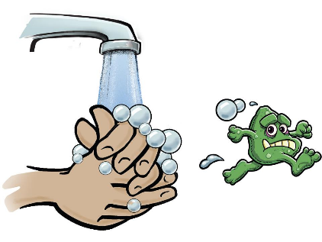
Medicspot is calling all primary school children to share their creative ideas to help encourage frequent hand washing – the best way to keep yourself and others safe from Coronavirus.
You could:
make a poster
write a poem
create a video
write / sing a song
do a science experiment
anything else you can think of
Find out how you can enter and win £500 for our school: www.medicspot.co.uk/handwash
Good luck everyone.

