Policy for Collective Worship

Leader/Co-ordinator | Miss P Malley
Groups involved in discussion | Headteacher  RE Co-ordinator  All Staff  Governing Body
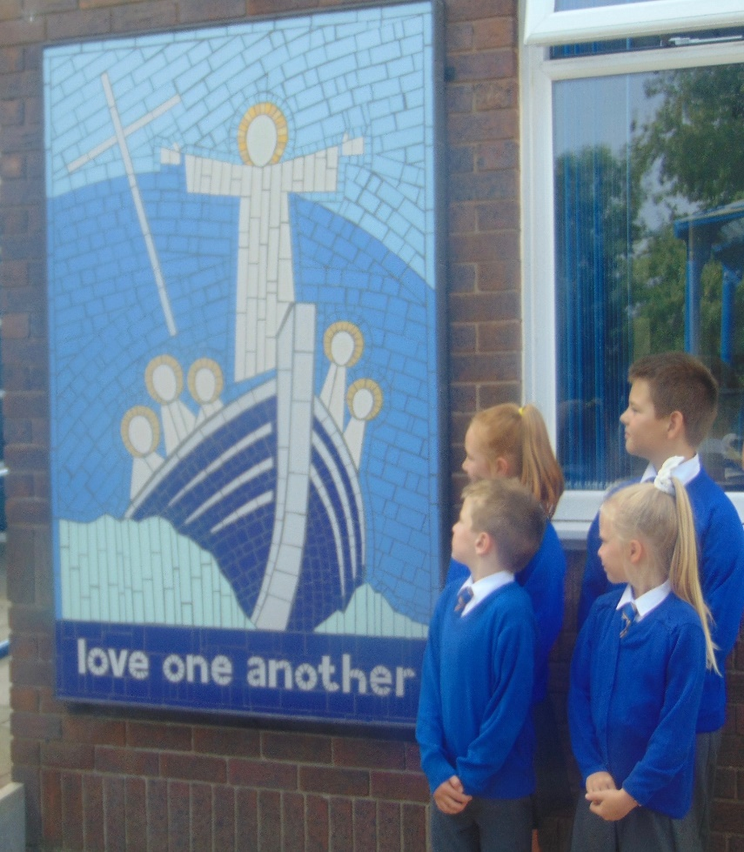
What is Collective Worship?

“Worship is concerned with reverence or veneration paid to a divine being or power.”
(Circular 1/94)

Collective worship at St Oswald’s provides opportunities for pupils and staff to come together to worship God. It is rooted in the example and teachings of Jesus Christ whilst taking into account the religious and educational needs of all who share in it. Collective Worship is an educational experience or a reflection to which all can contribute and from which all can gain.
• Those who form part of the worshipping community in church;
• Those for whom school may be their first and only experience of church;
• Those from other Christian traditions;
• Those from other faith backgrounds.

We understand worship to be a special act or occasion whose purpose is to show reverence to God our father, Jesus his son, Mary his blessed Mother and the wonderful world. Collective worship usually takes place in year groups to ensure that they are appropriate to their age; however, sometimes there are whole-school collective worships which are suitable for all children.
In line with the 1988 Education Reform Act, which states that Collective Worship should be wholly or mainly of a broadly Christian character’, we base our assemblies on the teachings of Christ and the traditions of the Catholic church. However we conduct our assemblies in a manner that is sensitive to the individual faith and beliefs of others.
While the majority of acts of worship in our school are Christian, we also hold assemblies that reflect other religious traditions that are represented in the wider and global community in line with the RE programme “Come and See”.

The Aims of Collective Worship

• To provide an opportunity for the children to praise and worship God;
• To enable children to consider spiritual and moral issues;
• To enable children to explore their own Christian beliefs;
• To encourage participation and response;
• To respond to and celebrate life;
• To develop the children a sense of community and faith;
• To promote a common ethos and shared values;
• To teach children how to worship;
• To build a firm foundation for liturgy;
• To enrich the religious experience of children and staff;
• To wonder at;
• To take time out;
• To come to terms with…

Who should be involved in Collective Worship?
- Pupils – they must have the opportunity to take part in daily Collective Worship.
- Teachers - they plan and enable Collective Worship to take place each day.
- All staff – they are invited to participate in all acts of Collective Worship.
- Parents – they too are invited to participate in acts of Collective Worship during class assemblies, meetings for Sacramental preparation etc.
Where should Collective Worship take place?

- In the classrooms
- In the hall
- In church
- In the Faith Garden
- In the open if appropriate
When should Collective Worship take place?

Collective Worship need not occur at the beginning of the day but rather at the time that is most appropriate for us as a school to ensure that it is a meaningful and prayerful opportunity for all participants.
How should Collective Worship be delivered?

- Can be led by pupils, staff or visitors
- Can be offered for a class, a year group, a phase or whole school
- Should use a balance of quiet reflection, silence, prayers, responses, music, songs, dance, drama, slides, video or short address
- Should provide a focus using artefacts, candles, symbols and lighting
- Ensures the theme, focus, delivery, length and resources are appropriate to the interests, age range, backgrounds and abilities of the pupils
- Respect the freedom of the pupils and staff in the invitation to prayer and worship
- Set an appropriate atmosphere with a sense of order and occasion, including entry and exit
- Ensure the possibility of conscious, active participation of all present

How should Collective Worship be planned, recorded and evaluated?
Planned
- Through with reference to the church’s seasons, significant dates and the Come and See curriculum.
- With the flexibility to respond to changing situations within the school and the wider community.
Recorded
- Through displays, prayers, photographs etc.
- Through planning to keep note of themes, leaders, pupil groupings.
- Planning is collected regularly and monitored by the RE co-ordinator.
Evaluated
- By staff and pupils on a regular basis.
- By SLT and RE co-ordinator.

Organization of Collective Worship

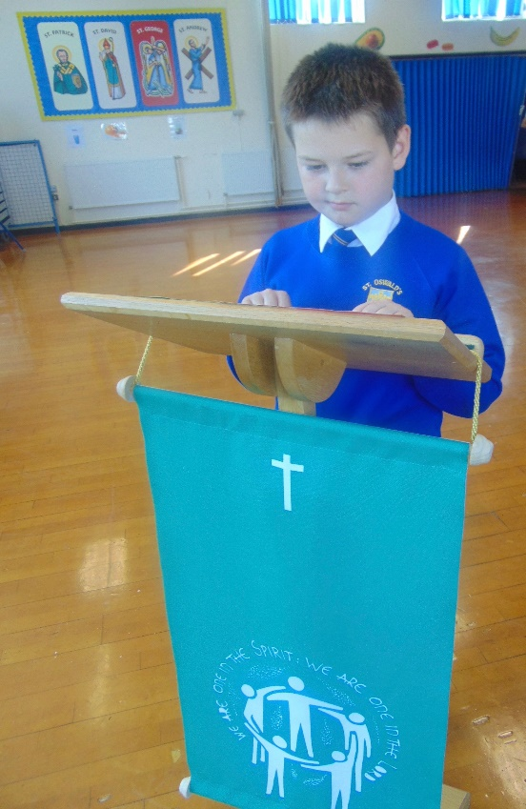
We conduct Collective Worship in a dignified and respectful way. We tell children that Collective Worship is a period of calm reflection. We regard it as a special time and expect the children to behave in appropriate way. Pupils are actively involved in planning and delivering acts of Collective Worship to their key stage. They plan each of the four sections Gather, Listen, Respond and Go Forth. Children are quiet and thoughtful and listen carefully to the teachings and participate fully in prayers and hymns. The pupils create an appropriate atmosphere by choosing music and sometimes candles or other objects that act as a focal point during the worship.

We take the themes of our Collective Worship from the traditions of the Catholic faith and we often reflect the feast days and events of the Catholic calendar. The RE leader provides a different theme for Collective Worship each month. Often the themes of our Collective Worship reflect and build on topics that we teach as part of the Come and See programme. We plan our assemblies based on the unit of work we are studying in the ‘Come and See programme.’

We welcome governor’s attendance at our assemblies any time.

Opportunities for Collective Worship

Opportunities provided for collective worship:-

Foundation Stage
Foundation stage staff sort their own collective worships within their own settings. The Foundation stage teachers deliver ‘Wednesday Word’ to the children in class, however, for celebratory masses the Foundation Stage children join the rest of the school in a whole-school assembly.

Key Stage One
Monday - In hall for Key Stage 1 Collective Worship (Delivered by a different class each week)
Tuesday - Within class setting
Wednesday – Wednesday Word in the hall- Whole school Collective Worship
Thursday - Within class setting
Friday - Within class setting

Lower Key Stage Two
Monday - Within class setting
Tuesday - Within class setting
Wednesday – Wednesday Word in the hall- Whole school Collective Worship
Thursday - In hall for Lower Key Stage 2 Collective Worship (Delivered by a different class each week)
Friday - Within class setting

Upper Key Stage Two
Monday - Within class setting
Tuesday - In hall for Upper Key Stage 2 Collective Worship (Delivered by a different class each week)
Wednesday – Wednesday Word in the hall- Whole school Collective Worship
Thursday - Within class setting
Friday - Within class setting

Whole School
Throughout the year pupils participate in mass, and deliver seasonal services for parents and members of the community Eg. Advent, Carol service, Ash Wednesday, Easter service, Corpus Christi, St. Peter and Paul etc.

Leavers
A special Mass is celebrated at the end of the academic year, which recalls the children’s journey through our school and points them towards their future lives in Secondary School.

Review
This policy will be reviewed on a yearly basis but maybe changed/updated at anytime, following discussions with staff, so that always remains a workable document.

Right of withdrawal
We expect all children to attend assembly. However, any parent can request permission for their child to be excused from attending religious worship and the school will make alternative arrangements for the supervision of the child during the period concerned. Parents do not have explain or give reasons for this. This complies with the 1944 Education Act and restated in the 1988 Education reform Act.
The Head teacher keeps a record of all children who withdraw from Collective Worship.

DISCUSSED AND AGREED BY RELEVANT STAFF
DISCUSSED AND AGREED BY GOVERNING BODY
MONITORING AND EVALUATION | Ongoing
REVIEW DATE(S)

